Q & A ABOUT Water

- Do all rivers come from springs?
Source - World Atlas https://www.worldatlas.com/articles/where-do-most-rivers-begin.html
Yes, all rivers come from springs. Rivers shape the ecosystem as they pass through and cause erosion on the riverbed. Flooding creates disposition of river. Naturally, catchment areas occur in high areas from which the water flows downwards due to gravity. Rivers may begin from a variety of sources including hills, mountains, lakes, snowmelt, and heavy rainfall. As the river flows downstream, other streams known as tributaries may drain into the main channel adding to the volume of water. Rivers may be seasonal or permanent depending on the capacity and nature of their source. Seasonal rivers flow mainly during the rainy season and dry up in the dry season.

Source - Texas Parks and Wildlife Department (TPWD) YouTube: Aquifers and Streams: Texas Aquatic Science – Chapter 7 (Hundreds or thousands feet below) https://www.youtube.com/watch?v=85Uv7Vi2iw8
Springs are found where underground water seeps on the ground and flows in the form of a stream, which eventually becomes a river.
2) What activities does mankind do that hurt rivers?

Source - Posted May 23, 2014 In Arizona Rafting, Colorado Rafting, Nature & Wildlife

- Straightening
- Channelization
- Industrialization
- Urbanization
- Agriculture

- Growing crops and storing uncontained products too close to river banks
- Increases sediments, which can be hurtful silt and contaminates
- Allowing cattle to graze by river banks
- Increases erosion by the elimination of plants and exposing soil
- Allowing cattle bathing, motorized vehicles and over swimming
- Increases the channelization separation, kills vegetation, and increasing e-coli in the river
- Pesticides and herbicides overuse and not aware of its consequences
- Increases loss of trees, plants and contaminates air, soil and water

3) Why do we need to protect rivers and improve rivers when they are rated as impaired by TCEQ?

Source - YouTube video by Our Thirsty World National Geographic:
https://www.youtube.com/watch?v=2pXuAw1bSQo

- To make rivers safe for people to use, or even to be more enjoyable to view while walking or passing over a bridge.
- To protect the river ecosystem (Which includes humans and earth.)
- To help plants flourish (Plants give oxygen and stop erosion)
- To allow animals to thrive (They cannot go to a store to buy food.)
- To keep pollution out of rivers. (The more there is fresh clean water, it will flush out pollutants and the native plants will help filter groundwater. And to keep debris from blocking water flow.)
- To maintain clean fresh drinking water (Without fresh clean water nearby, costs of water will go up.)
- To keep agriculture costs down (If the cost of water costs goes up, food costs goes up.)
- To protect geologic, ecological, biological and human history (Cities will die.)
- To shape culture and societies (We will die if we don’t have water areas.)
- To transport. (Water bodies are used for transportation and navigation.)

Source – 2020 Netflix video on YouTube: https://www.youtube.com/watch?v=C65iqOSCZOY

It is true we will die without water. We will have a world water crisis if we don’t manage the problem now. In 2020, the very rare fresh water resources is utilized for:

- 70% Agriculture
- 22% Industry
- 8% Personal

4) Are aquifers contaminated with herbicides and pesticides?

Source - Texas Water Development Board YouTube: https://www.youtube.com/watch?v=4-zb74_9Hqo

Source: Texas Water Development Board YouTube: Aquifers Explained https://www.youtube.com/watch?v=1HJ5Q2yH5S8

Mieko Mahi’s conclusion is the answer is yes. However, some countries such as Canada, who have fresh water readily available from icebergs, would most likely not be contaminated.

Contamination can be from a point source or nonpoint source area. Point source is caused from a specific location. Nonpoint can fluctuate and be hard to detect. Clean ups are costly and in most cases can never be completely cleaned.

5) What should we know about water?

Source – Robeco Asset Management YouTube: Water our most precious resource: https://www.youtube.com/watch?v=VIaw5mCjHPI

Source – United States Environmental Protection Agency (EPA) https://www.epa.gov/ccl/types-drinking-water-contaminants#:~:text=These%20contaminants%20may%20be%20naturally,as%20microbes%20or%20microbiological%20contaminants.

Source - Bozeman Science - Water resources https://www.youtube.com/watch?v=IDAj5T1ST7o

We should know:

- Water is the same water that was here from the beginning of time, it is finite and recycles through plants, to rain, and back to earth and then back again.

- We should know where our drinking water comes from.

- Water is so cheap; farmers could be paid for conservation of it because of this fact.

- Water resources move through a hydrologic cycle: Seawater, fresh water, and ocean circulation.

- Fresh water can be found in ground water or surface water, which is used for domestic, industry and agriculture.

- We can store surface water through reservoirs; aquifers are our ground water.

- Aqueducts and irrigation help move that water.

- Conservation is important and economics drive conservation, in other words, if water becomes more expensive, the less we’ll use.

6) Why does farm micro irrigation keep coming up for conservation solutions; as well as, river discharge industrial infiltration?

Source - Robeco Asset Management YouTube https://www.youtube.com/watch?v=VIaw5mCjHPI

Source - Texas Water Development Board YouTube Part 1: Aquifers Explained
https://www.youtube.com/watch?v=1HJ5Q2yH5S8

Watch online information videos for possible solutions. Note, about 3 minutes in, the 2nd video – it mentions that water flows from the rivers or lakes into the aquifer.

Source - Texas Water Development Board YouTube Part 2 https://www.youtube.com/watch?v=RCu4UWDiiQw

Source - Texas Water Development Board YouTube Part 3 https://www.youtube.com/watch?v=4-zb74_9Hqo

Water conservation and economics drive the need for cost-effective technology.

7) What is considered a drinking water contaminate?
On the EPA website, it reads: The Safe Drinking Water Act defines the term "contaminant" as meaning any physical, chemical, biological, or radiological substance or matter in water. Therefore, the law defines "contaminant" very broadly as being anything other than water molecules. Drinking water may reasonably be expected to contain at least small amounts of some contaminants. Some drinking water contaminants may be harmful if consumed at certain levels in drinking water while others may be harmless. The presence of contaminants does not necessarily indicate that the water poses a health risk.
Only a small number of the universe of contaminants as defined above are listed on the Contaminant Candidate List (CCL). The CCL serves as the first level of evaluation for unregulated drinking water contaminants that may need further investigation of potential health effects and the levels at which they are found in drinking water.
Learn about contaminants that are currently regulated
How EPA regulates drinking water contaminants
The following are general categories of drinking water contaminants and examples of each:
- Physical contaminants primarily impact the physical appearance or other physical properties of water. Examples of physical contaminants are sediment or organic material suspended in the water of lakes, rivers and streams from soil erosion.
- Chemical contaminants are elements or compounds. These contaminants may be naturally occurring or man-made. Examples of chemical contaminants include nitrogen, bleach, salts, pesticides, herbicides, metals, toxins produced by bacteria, and human or animal drugs.
- Biological contaminants are organisms in water. They are also referred to as microbes or microbiological contaminants. Examples of biological or microbial contaminants include bacteria, viruses, protozoan, and parasites.
- Radiological contaminants are chemical elements with an unbalanced number of protons and neutrons resulting in unstable atoms that can emit ionizing radiation. Examples of radiological contaminants include cesium, plutonium and uranium.

8) Is it true or false that EPA does not control or test for herbicide and pesticide in our drinking water or any body of water in the United States?

Source – EPA website https://www.epa.gov/privatewells
Source – TCEQ website https://www.tceq.texas.gov
False, but it varies: Ground water under the direct influence of surface water is susceptible to contamination from activities on the surface. Direct influence is determined on a site-by-site basis under state program criteria. To find a state agency to contact, please click here: https://www.tceq.texas.gov/response/drought/groundwater_regulation.html

Groundwater Regulation for Private Well Owners
TCEQ - Explains how groundwater production and use is managed and regulated in Texas.
State law does not provide any state agency with the authority to regulate the use or production of groundwater. Groundwater production and use is managed and regulated by local or regional groundwater conservation districts (GCDs).
Areas that are not within a GCD are subject to the rule of capture that essentially provides that groundwater, once it has been captured by a well and produced to the surface, belongs to the landowner. Limitations to the rule of capture include:
- Capture and use of groundwater cannot be done maliciously with the purpose of injuring a neighbor or amount to willful waste of the resource
- A landowner is liable for damages if his negligent pumping of groundwater results in the subsidence of neighboring land (that is, lowering in elevation of the land surface caused by the withdrawal of groundwater)
9) Is it true or false herbicides and pesticides kills plants, humans, insects, wildlife, air, land and water?

Source – World Atlas website: https://www.worldatlas.com/articles/what-are-the-major-sources-of-groundwater-contamination.html

True according to World Atlas. False according to EPA, if the label is followed. However, Mieko Mahi , a concerned citizen that is a layperson speaking from the heart, says, “Location and quantity has been proven to be overlooked in training. Including those that have authorized it, as they are not aware of the location it’s being used or aware of how quantities impact environment. The consequences are overuse and mishandling of herbicides in cities or anywhere on earth. There is lack of information on what herbicides do to humans and wildlife.”

Effects of Contaminated Groundwater
WorldAtlas - Contaminated groundwater can lead to severe effects on the environment, animals, and human beings.

Firstly, groundwater is the primary source of drinking water for most people and animals around the globe. Once the groundwater is contaminated with harmful chemicals and bacteria, the humans and animals consume the harmful substances through drinking water and subsequently suffer health problems such as amoeba, typhoid, diarrhea, and even cancer.

Secondly, the trees and vegetation that rely on groundwater are likely to dry up after absorbing contaminated water. As a result, the loss of vegetation leads to an imbalance in the ecosystem.

Thirdly, contaminated groundwater may seep into rivers and streams and lead to the loss of marine life, which is detrimental to the environment.

Lastly, when groundwater is contaminated with reactive substances, it may result in harmful chemical reactions that destroy the soil around the area. The consequences of destroyed soil include poor plant development and bad soil quality.

10) Is it true or false pollution destroys our drinking water:

Source – World Atlas website https://www.worldatlas.com/articles/what-are-the-major-sources-of-groundwater-contamination.html

It is true pollution destroys our drinkable water.

Major Sources of Groundwater Contamination
For a long time, groundwater was known to be clean and free from contamination. However, due to rapid industrialization and increased use of chemicals, numerous contaminants often find their way into the groundwater. The significant sources of contamination in groundwater are farming chemicals, septic waste, landfills, uncontrolled hazardous waste, storage tanks, and atmospheric pollutants.

Agricultural Chemicals
Agricultural production has been scaled up in most developed nations. This large-scale production of farm goods means increased use of farm chemicals such as pesticides, herbicides, and fertilizers. These chemicals used on farms settle on the ground, and when it rains, they mix with the rainwater and seep through the porous ground to reach the underground water. That way, the chemicals pollute the groundwater.

Septic Waste
It is essential that septic waste is treated before it is disposed into the ground. Treatment prevents harmful substances from getting into the ground and spreading to the water. Additionally, the septic systems are structured to release the waste into the ground at an extremely slow rate, which is harmless to the environment. However, poorly designed septic systems release viruses, bacteria, and household chemicals into the groundwater and make it unfit for human consumption. Poorly maintained septic tanks also result in leaks, which cause groundwater contamination.

Landfills
As the human population grows, so does the garbage produced daily. This garbage is collected and taken to particular locations known as landfills where it is buried. Landfills are required to have a protective layer at the bottom to stop the waste from seeping into the ground. Nonetheless, some landfills lack that protective layer, and in some cases, it is cracked. Such landfills result in leaks of contaminants such as household chemicals, car battery acid, oil, and medical products into the groundwater.

Hazardous Waste Sites
There are numerous sites around the world where hazardous products such as radioactive components, war chemicals, electronic waste, and similar products are disposed. The number of these waste sites keeps growing by the day. In many cases, hazardous products’ disposal sites are not adequately monitored. The lack of proper monitoring and maintenance of such sites leads to leakage of dangerous substances into the groundwater.

Storage Tanks
Chemicals, oil, minerals, and other products are often kept in storage tanks above or below ground. In the United States alone, it is estimated that more than 10 million storage barrels containing different substances are stored underground. Over time, the storage containers erode, and this may result in harmful substances leaking into the ground. Subsequently, the contaminants move through the soil and reach the groundwater making it unfit for human use.

Atmospheric Pollutants
Groundwater is maintained through the hydrological cycle , which is the movement of water above, below, and on the surface of the earth. As the water moves, it comes into contact with pollutants in the atmosphere such as harmful gases. When it rains, the water carries these contaminants into the ground and pollutes the groundwater.

Underground Pipes
As nations develop, they invent new methods of transporting different products using the underground pipes. Products such as oil, farm chemicals, cooking gas, and drinking water are mainly transported through underground pipes. In many instances, the underground pipes burst and release their content into the ground. These incidents often lead to groundwater contamination.

Road Salts
Road salts are mainly used in places that have snowfall during winter. Road salts are chemical products are used to melt ice on the road. Once the ice melts it flows with the chemicals through the ground and into the groundwater hence contaminating the water.

11) What are the key natural affects of rivers?

Source - UK Groundwater Forum YouTube
https://www.youtube.com/watch?v=ci-ABWPG7LQ

How rivers work: The role of Groundwater:

- Rain benefits river with flow
- The catchments high up is where the river begins
- Permeable rock impacts structure
- Water table impacts river bed and water wells
- Ground surface water level
- Ground water level
- Some rivers begin with a soggy seep or spring
- Rivers dry up in summer which can cause rain not to reach the water table
- In summer, rain is less likely to reach the water table because of evaporation
- Heavy rain and flooding is needed for nutrients and for rivers and ponds to flush out pollution. The benefits refills ponds, wells, river, groundwater and aquifers with fresh water
- Lack of rain can causes droughts, which can create navigation problems, spoils the views when walking or crossing bridges, reduce ability to dilute effluent into rivers, create inability to maintain plants, impacts insets, wildlife and humans

The point is rain reaches groundwater. For more information about rain water:

Source – Susan Evans Groundwater Experiment https://www.youtube.com/watch?v=0O0DQhsMXwI

Source – Northern California Public Media What is ground water? https://www.youtube.com/watch?v=83qBb7KRkAE

Groundwater Foundation GWFDN
https://www.youtube.com/watch?v=g3OEi0rk9QQ

A CouRse about the Lavaca River:

Source Lavaca-Navidad River Authority (LNRA) Patrick Brzozowski, GM and Chad Kindsfather, Director of Environmental Services during the Nov. 5, 2020 Lavaca River & Rocky Creek Watershed Protection Program Annual Stakeholder (virtual) Meeting (WWP)

The source of the Lavaca River are springs at the headwaters of the lower section Gonzales County and Fayette County, now there is more ground water in certain parts, as water runs 50 yards down and comes up in Hallettsville’s section. It has more wastewater effluent in a drought situation.

It was explained that the aquifer in sections is the Carrizo-Wilcox Aquifer for Hallettsville. And parts of the county have access to the Gulf Coast Aquifer. Also the water utility is “pumped from ground water”, says Patrick.

Discussing the river water quality, Patrick said we could drink the treated wastewater, but Chad said he wouldn’t do it. The City of Moulton has their wastewater treatment flowing into the Lavaca River, which is north of Hallettsville, and so does the City of Hallettsville’s wastewater treatment, which is located, south of 77/90 bridge. Both treatment plants have treated effluent discharge into the Lavaca River.

Patrick said LNRA has water rights and is utilizing the Lavaca County river water for agriculture. Riparian rights owners have access to DNL water rights. LNRA has Major Rights for irrigation to the Old Roberson property. Patrick said that all rivers have water rights and are being utilized all along the Lavaca River. He said that that in the Lavaca County section of the river, there are different river mouths crossing over different soils with cow manure. TCEQ has listed the Lavaca as the worst impairment of water quality in Texas. Patrick said “Being classified as impaired is not bad. He added, “I wouldn’t advise drinking any river water or Hallettsville’s river water. “

At the Nov. 4, 2020 Stakeholder Meeting to Develop Local Vegetation Plan Invitation by Michael Jansky, President, Flood Control Board District No. 3, it was brought up by LNRA that the river quality was the same as the area’s ponds, which is filled with E-coli and other bacteria, that the water quality was all the same due to run off from rain as it passes through pastures of cow manure and agricultural land.

Nov. 5, 2020 Lavaca River & Rocky Creek Watershed Protection Program Annual Stakeholder (virtual) Meeting (WWP) - it was explained by Emily Monroe, Program Specialist, Texas Water Resources Institute, http://twri.tamu.edu/ -
it was explained - that the Lavaca River quality in Lavaca County was impaired and it was the highest possible for impairment. When it was questioned if public was informed, the reply was everyone knows this already. It was also brought up that there was State law for communities to repair their water quality. LNRA General Manager brought up illegal dumping and said it was up to community to clean up and that if people wouldn’t dump on the road, it wouldn’t get in the river.

He said that it was not their job to clean up yet they would assist and that it is an ongoing problem as people dump a lot into the river.

At the Nov. 4, 2020 at the Stakeholder Meeting to Develop Local Vegetation Plan Invitation by Michael Jansky, Flood Control Board District No. 3-- before it started, Mieko Mahi discussed with Patrick, LNRA GM, about creating observer teams along the river. Patrick said he would assist with whatever was needed to create teams. He stated, again, at the WPP Nov. 5th meeting that it would be good to have the land owners be on the clean up for trash teams. Patrick stated that trash pickup and the issue of dumping in the river, it is a voluntarily community issue to work out.

At the Nov. 5, 2020 Lavaca River & Rocky Creek Watershed Protection Program Annual Stakeholder (virtual) Meeting (WWP), Emily Monroe, shared with Mieko Mahi, that The WPP meeting is funded, and the funding is to focus only on E-coli and Dissolved Oxygen, and it was discussed after meeting that the Herbicide and Pesticide use is not funded and is not discussed at these meetings. When Mieko asked about the need for less use of herbicides and pesticides, Patrick said to seek funding through a USGS grant, if contaminate testing and discussion is wanted. Testing for herbicides is not monitored or done. It has been stated that herbicides and pesticides are found in all water sources, ponds, river, springs, say Patrick. Testing for herbicides would have to come from USGS grant. It was mentioned to contact Dept. of Agriculture if we had concerns for herbicides.

In conclusion for this Lavaca River course, the sections of where the headwaters begins needs love and care. We have been left out of the conversation for improvements, so in order to gain those improvements, we need to embrace and talk positively about the Lavaca River in order to bring in more people to volunteer and to even want improves “, explains Mieko Mahi.

((In Dec. 2020, Mieko learned from TCEQ monitor expert in Austin, that the oxygen level is good for wildlife in Hallettsville and it is not good in Moulton. Mieko has been trying to get confirmation of this data to make sure it is the correct area, because this is so positive for Hallettsville, for the water quality to be a living river. The river does look "clear" this month of December 2020. And Mieko is surprised that Moulton's water's oxygen is not good for wildlife. At this time, we need someone to explain this and too, prove which monitors provided this information to TCEQ, and too, explain if this is something that continues to fluctuate, as in never stays the same for Moulton and Hallettsville. An educated guess is that it fluctuates as we receive 4 " rains. And Mieko doesn't totally understand how pumping "out" the water impacts Hallettsville's section of the river for irrigation. I heard one person say, it doesn't impact us, but I still don't understand how if our river is low, how using it faster than we have a level is good, only an engineer could explain this. Because what is on a lot of people's mind is, what happened to the river depth. A lot of people say it needs clearing of sand, other say leave it alone. Looking at the FEMA maps, a large section of Hallettsville will flood. Mieko has been trying to get confirmation, what the improvements have been, what they need to be now. And until an engineer is hired, we can only guess that we will flood in the 100 year flood map. That means we have a 100 percent chance of flooding within 100 years. As far as Hallettsville section of the River, Mieko Mahi and Milton Mache saw a two foot gar, an aged large turtle, a water snake, and a clam, numerous wildlife footprints, gazillion minnows. And the presence of Horse Tail plant proves the underwater stream is "consistently" in place, otherwise it would be dead. Horsetail only thrives on land where there is consistent water. It is a fast read to find out how the underwater system is doing. Note that when we started researching Horsetail was said to be evasive and from our research it is not evasive, it is a good plant to have, it is desirable as a food source and shelter and it does not cause flooding as it will lay down in high water. Right now in December 2020 all the plants froze and died from above the roots, it will be interesting to see what happens when we receive high water, if it will break off the stems downstream or not. What has been happening, is spraying of herbicides, and the stems break off. If these stems break off, then freezing is the same effect without poison. From what I understand, El Campo Spraying is not changing their price to pinpoint a few plants instead of taking out all plants..they are charging the same. It made sense at first, but after review of the plants that need to go, stand out, and are easy to spot, so it should be way cheaper to spray just the plants that are considered approved to spray by Texas Parks and Wildlife. )

At the Nov. 5, 2020 Lavaca River & Rocky Creek Watershed Protection Program Annual Stakeholder (virtual) Meeting (WWP) Partrick said The only people that talk negatively is a group in Hallettsville”. Mieko called Emily Monroe after the meeting as asked, “Who is the group that talks negatively about the river?” And is waiting for the reply.

Mieko says, “We need to change the conversation to embrace our river, how it works and how we can work to bring up the water quality to not pollute our ground water which is being pumped for our drinking water, as Patrick explains Hallettsville is getting water from ground water and the Carrizo-Wilcox Aquifer in sections, and as we just learned, the watershed river water and treatment waste water is being sold for water rights downstream”, says Mieko Mahi

Best management programs funded by nonpoint TCEQ program, and implemented from EPA through Texas Water Resources Institute and Texas A & M.

Texas Water Resources Institute
twri.tamu.edu
Texas A&M AgriLife Research
Texas A&M AgriLife Extension Service
Texas A&M University College of Agriculture and Life Sciences

Emily Monroe, Program Specialist, explains:
- Education programs being planned in watershed in the Lavaca Basin area for 2021 by TWI:
- In person meetings,
- Streamed live at the same time in early spring

- Illegal dumping and education program
Education Campaign
- Ground water education (Mainly through Texas Network) learning to protect well water and testing

Lavaca County must restore their water bodies voluntarily, Lavaca River Watershed Plan covers education, and information about sources for funding and issues about water quality.
To see the Lavaca river Watershed Website, check it out online
Their Goal is Education and Outreach and to work with protecting resources to reach standards

Mieko Mahi's recommended water information resources:

Source – Netflix 2020 Worlds Water Crisis https://www.youtube.com/watch?v=C65iqOSCZOY

Source – City of Hallettsville : http://cityofhallettsville.org/wp-content/uploads/2020/06/2019-Consumer-Confidence-Report-Annual-Water-Quality-Report.pdf?fbclid=IwAR1pe7Ybh09LD8Cgm8kTIMZbBVy8IhdpNKp0sugDU9VzgALbalgWIXf8bNc

Funding education:
The funding is from the State Water Implementation Fund for Texas (SWIFT). The program was created by the Texas Legislature to support projects in the state water plan with affordable financial assistance.
Reference:
TWDB Approves $222M in Funding for Corpus Christi ...

Every year, EPA awards more than $4 billion in funding for grants and other assistance agreements. From small non-profit organizations to large state governments, EPA works to help many visionary organizations achieve their environmental goals. With countless success stories over the years, EPA grants remain a chief tool to protect human health and the environment.

Referred by LNRA Links: google earth
https://www.tshaonline.org/handbook/entries/lavaca-river
https://www80.tceq.texas.gov/SwqmisWeb/public/crpweb.faces
https://www80.tceq.texas.gov/SwqmisPublic/public/default.htm - did not work
https://www.tceq.texas.gov/assets/public/waterquality/nps/watersheds/LavacaWPPApril2018.pdf - 2018 report
http://www.lnra.org/docs/water-quality-program/2020-lavaca-basin-highlights-final-report-(1) - 2019 report revised from meeting

Lavaca River in Lavaca County, described Chad Kinsfather 8/18/2020, Director of Environmental Services, Lavaca-Navidad River Authority”

“The Lavaca River begins on the corner or Gonzales and Fayette counties, if you type in those coordinates that you looked at on the TSHA website, the river comes up in Fayette county--20 miles to the East of Gonzales. The rivers that are near Gonzales are the San Marcos and Guadalupe.

The Lavaca River is on the 303d list for not meeting EPA Tier1 standards for bacteria, but to designate the cause to "leaking toilet line" is a misnomer that can lead to wasted resources and time chasing a leak that does not exist. The majority of the Lavaca watershed is rural, domesticated animals and wildlife use the water as a drinking source, which can contribute to elevated bacteria levels. A leaking sewer line is considered a point source; the e-coli levels would be linear from month to month, not pervasive.

A copy of the 2020 Basin Highlights Report is on our website, that would be a good place to start reading to educate on the issues associated with the Basin. “

“… bacteria is a naturally occurring organism in all warm and cold blooded living things.” – Chad Kinsfather.

10/1/2020 - “LNRA is the primary water quality collector on the river, other entities (TCEQ, academia, TPWD) might collect data from time to time. We collect conventional data quarterly and field data monthly, all of this can be found in the BHR. Either way, all of the data is stored on a database with TCEQ. There is a link on our website that will access this data, a map of all sampling locations is provided and the data may be queried numerous ways (date, parameter, year, etc.).

The sand banks in the river channel are deposited there naturally, they will shift from event to event. Water concerns should be shared with LNRA. Anything to do with wildlife always contact TPWD.

That is about all the answers I can provide you, hopefully somebody will be able to help out with the rest.” – Chad Kinsfeather, Director of Environmental Services

See FY2020 monitoring map and monitoring schedule.
See description on the FY2020 Basin Highlight Report on page 17.

Chad replied to Mieko Mahi’s questions on e-coli, “The only way to determine the source of bacteria is to incorporate bacteria source tracking (BST) monitoring. This is an extremely expensive monitoring approach that LNRA will consider, after the WPP concludes.”
When asking about understanding the readings, the reply is “All of the data is submitted to TCEQ and approved can be found here:
http://www.nueces-ra.org/CP/LNRA/SWQM/ or http://www80.tceq.texas.gov/SwqmisPublic/public/default.htm

When asking about monitors where the flow begins in Gonzales and Fayette County, the reply is: “There are no monitoring stations that high up, there is not enough flow to warrant monitoring (intermittent). Intermittent streams are defined as having either a period of zero flow for at least one week during most years or a seven-day, two-year low-flow (7Q2) less than 0.1 ft3/s (where flow records are available).

When asking about the distance of river in the headwaters the reply is: “Google Earth is your friend here. Headwaters to Moulton = 2.9mi, Headwater to Hallettsville = 25 mi, Headwater to Edna = 86mi.”

When asking about where e-coli is coming from, the reply is: “One way is to look at the readings and understand the readings. If it were this simple, I would have solved this issue many years ago. Let the WPP work, this issue is not going to be resolved overnight or even a year.”

When asking about soil and water testing for contaminates for herbicides/pesticides, the reply is: “Herbicide and pesticide sampling are an expensive endeavor, a grant from USGS is highly advised.”

When asking about the segments numbers and classification of the river, the reply is: “Classification is a numerical value given to a segment. All water bodies in the state have been divided into segments based on regional hydrologic and geologic diversity, which are referred to as classified or designated segments.”

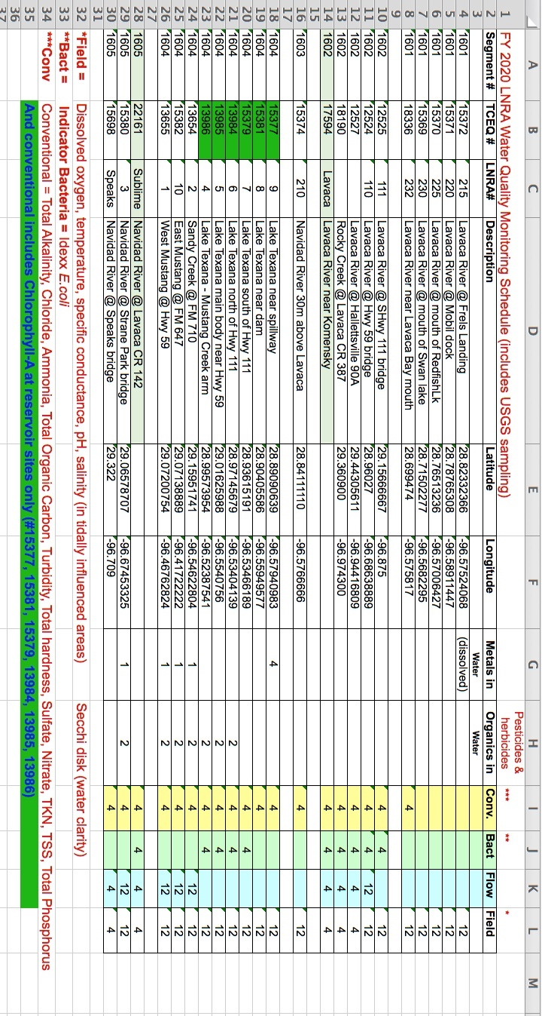
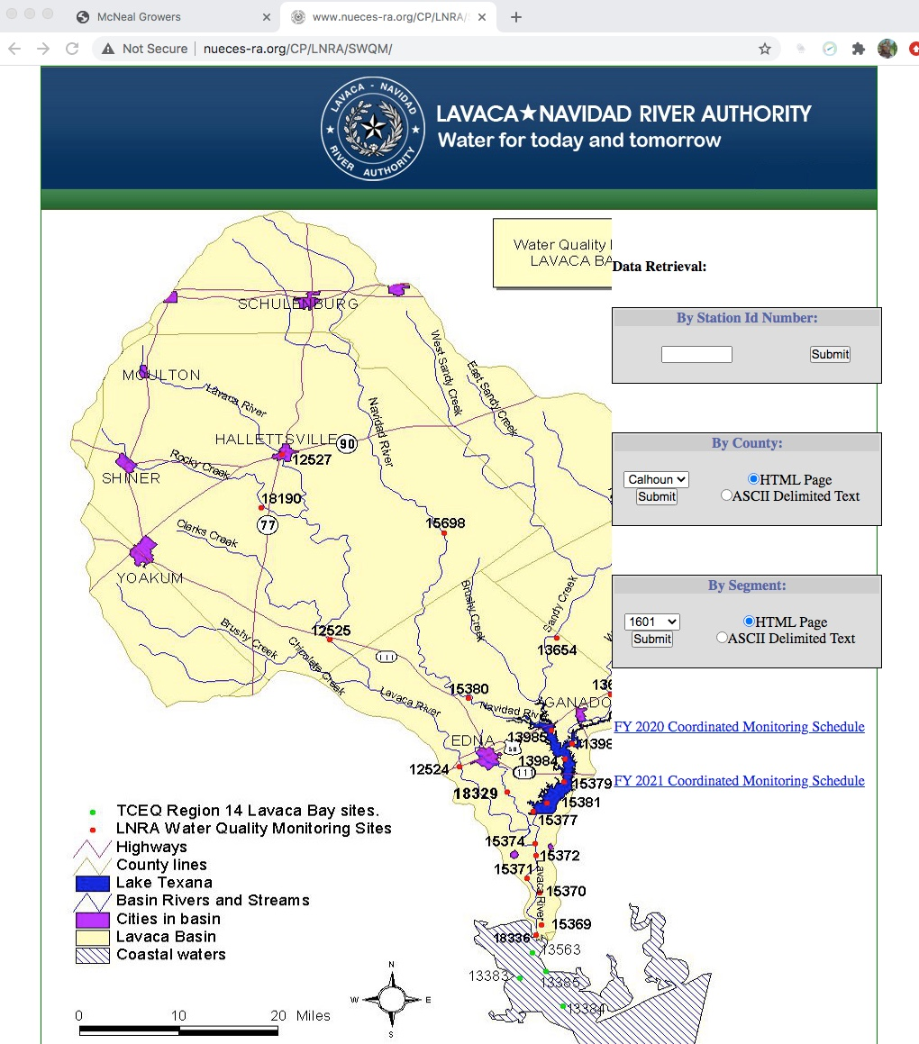
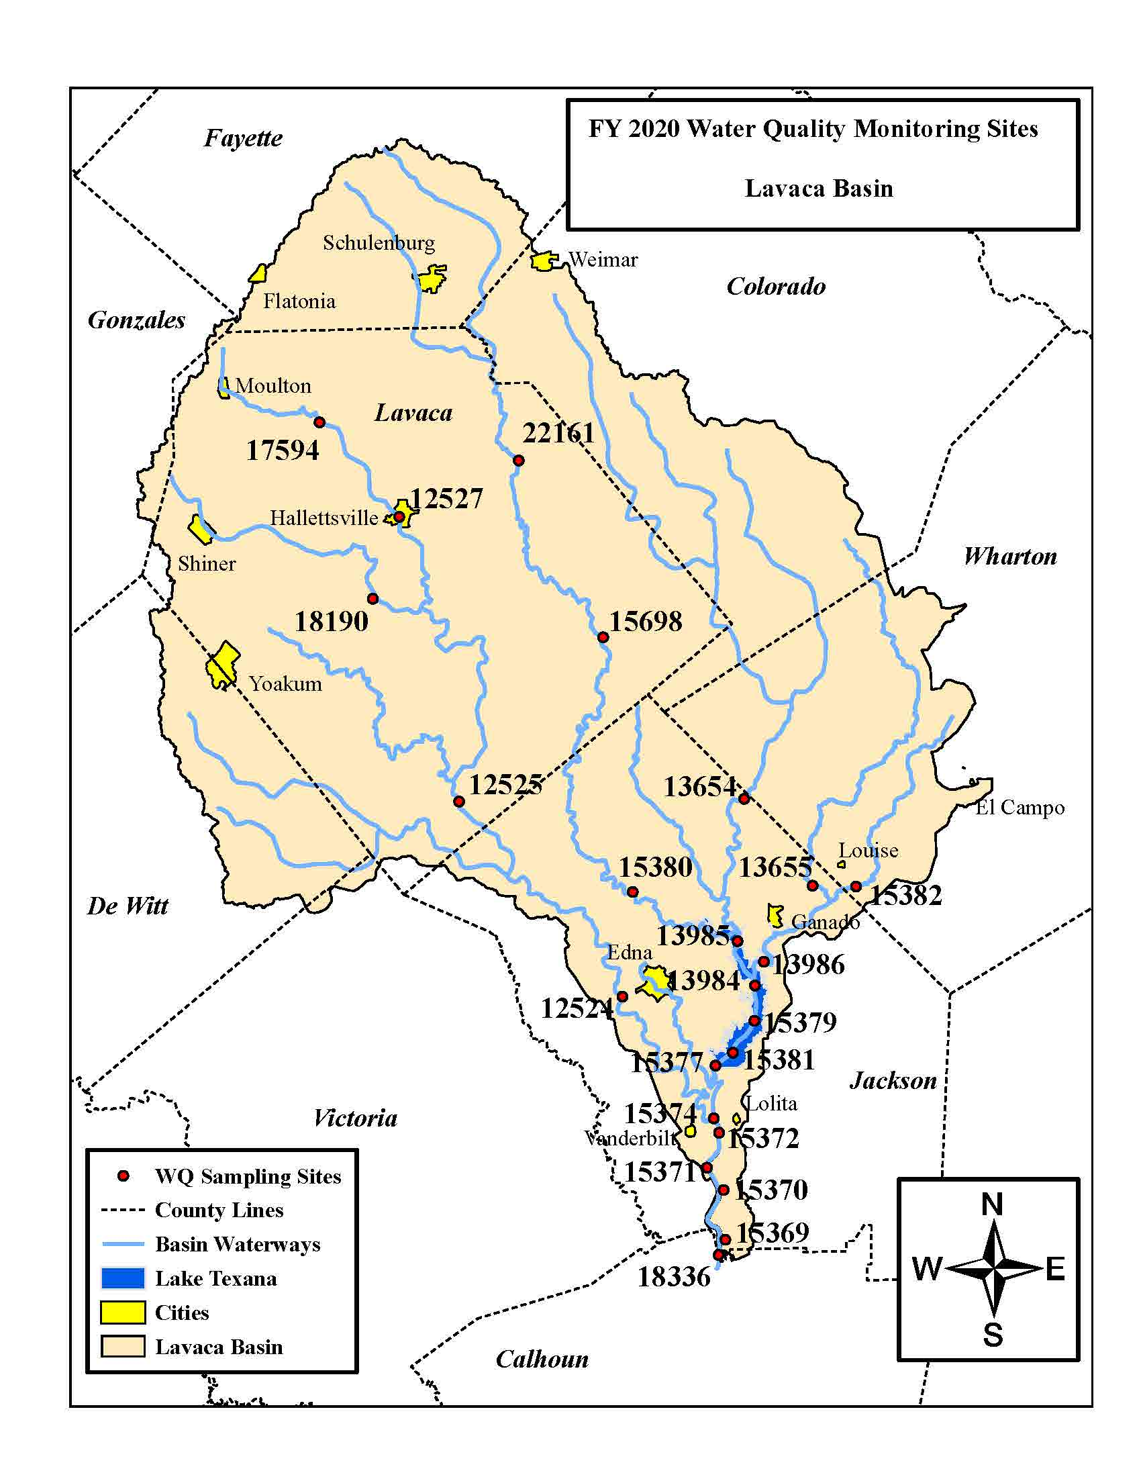

About PRIVATE DRINKING Water Wells

Source - TCEQ https://www.tceq.texas.gov/response/drought/groundwater_regulation.html
It is estimated that more than 13 million households rely on private wells for drinking water in the United States (US Census American Housing Survey 2017). EPA does not regulate private wells nor does it provide recommended criteria or standards for individual wells. EPA offers information regarding the importance of testing private wells and guidance on technologies that may be used to treat or remove any contaminants.
Private well owners are responsible for the safety of their water. This website educates well owners on wells, groundwater, and information on protecting their health. This website also provides links to other federal and non-profit websites that host additional educational materials and resources to help private well owners.

Testing wells to safeguard your water

Testing frequency
Test your private well annually for total coliform bacteria, nitrates, total dissolved solids, and pH levels. If you suspect the presence of other contaminants, you should test for those also. You can also contact your local health department to find out what substances may be common in your area's groundwater.
You may want to test more frequently if small children or elderly adults live in your house or if someone in your house is pregnant or nursing. These segments of the population are often more vulnerable to pollutants than others.
You should also test your private well immediately if:
- There are known problems with ground water or drinking water in your area
- Conditions near your well have changed significantly (i.e. flooding, land disturbances, and new construction or industrial activity)
- You replace or repair any part of your well system.
- You notice a change in your water quality (i.e. odor, color, taste).
In addition, well owners should also determine if the ground water you rely on for household use is under direct influence from surface water. Ground water under the direct influence of surface water is susceptible to contamination from activities on the surface. Direct influence is determined on a site by site basis under state program criteria. To find a state agency to contact, please click here.
https://www.tceq.texas.gov/response/drought/groundwater_regulation.html

Groundwater Regulation for Private Well Owners
TCEQ - Explains how groundwater production and use is managed and regulated in Texas.
State law does not provide any state agency with the authority to regulate the use or production of groundwater. Groundwater production and use is managed and regulated by local or regional groundwater conservation districts (GCDs).
Areas that are not within a GCD are subject to the rule of capture that essentially provides that groundwater, once it has been captured by a well and produced to the surface, belongs to the landowner. Limitations to the rule of capture include:
- Capture and use of groundwater cannot be done maliciously with the purpose of injuring a neighbor or amount to willful waste of the resource
- A landowner is liable for damages if his negligent pumping of groundwater results in the subsidence of neighboring land (that is, lowering in elevation of the land surface caused by the withdrawal of groundwater).

